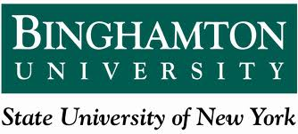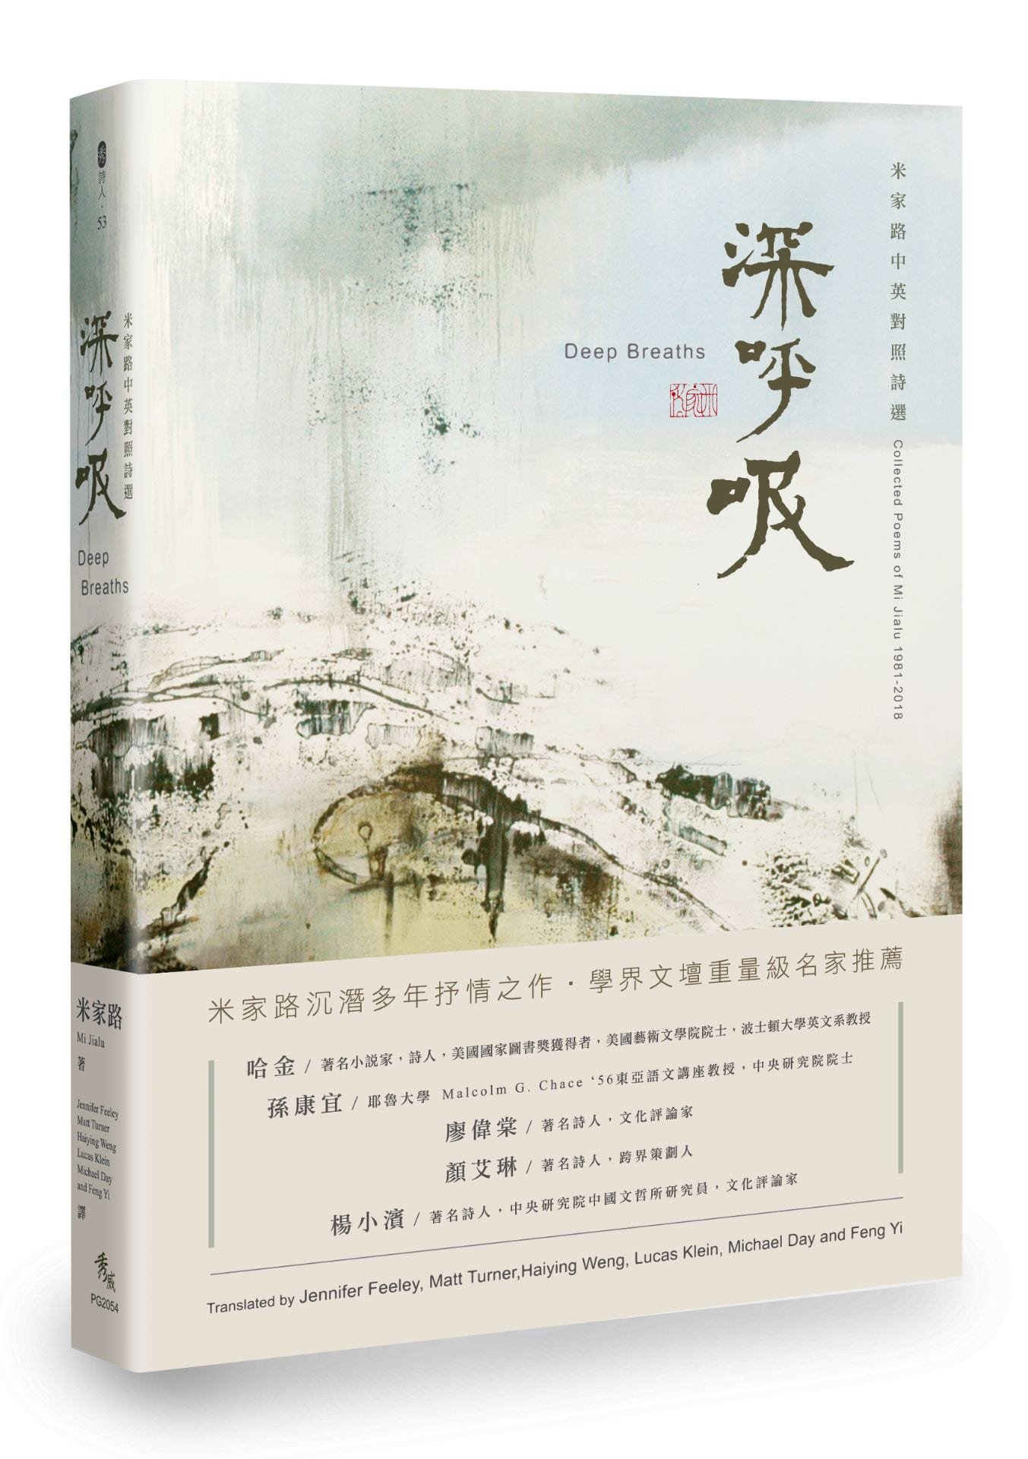

|  |  |  |
| --- | --- | --- |
| Wednesday 11.6.2019 | Fine Arts bldg.Room 258 | 3:00-4:30 |

### Sponsors: the chinese studies program, department of asian & asian american studies

### *And*

### Confucius institute of Chinese Opera

# *Bilingual Poetry Reading & Performance by*

Jialu Mi

# (米家路)

**From his new Chinese- English bilingual collection of poems:**

***Deep Breaths***

深呼吸