# BINGHAMTON UNIVERSITY Partners with

# Christ (Deemed to be University), Bengaluru, India, Louisiana Tech University, Grambling State University, and Catholic University of Applied Sciences North Rhine-Westphalia,

# Germany for the Let Us Dream 2020 Virtual Triennial International Conference

# November 20-22

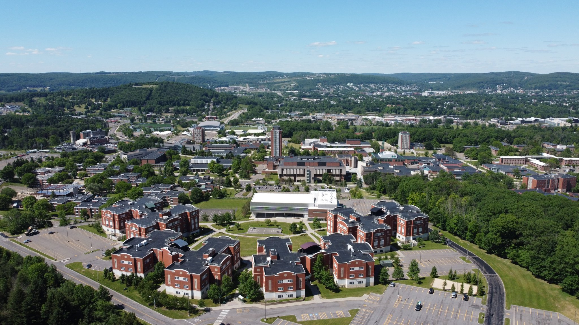

September 30, 2020

BINGHAMTON, N.Y. — This year will mark the first virtual Triennial International Let Us Dream Conference. The free international conference offers an opportunity to explore and share the many and varied community-service possibilities and intervention models, as well as volunteer opportunities for younger and older generations. The primary intent is to create an inclusive, diverse, cross-cultural environment for sharing and growth through community improvement discourse among scholars, practitioners, and volunteers of all ages. This year's conference will be a three-day event focusing on education, health and social community improvement initiatives.  
  
Mark your Calendar for November 20, 21 and 22, 2020 (Friday - Sunday) from 8:30AM to 11:00AM EST (Eastern Standard Time) [Registration](https://docs.google.com/forms/d/e/1FAIpQLSd2qn0gzALanC7Tl9Nd90x0FRlNxCZ_Cf1bDHLfMHtny-zY9w/viewform) is required.

The Let Us Dream Conference is hosted to:

1. Empower people of diverse age groups and backgrounds working in a myriad of community improvement programs aiming at a better tomorrow.
2. Bring together the concepts and findings of researchers with the real-world experiences of practitioners, providing relevance to and synergizing combined knowledge.
3. Promote community service and learning among students by introducing diverse interventions.

Each day will feature two internationally renowned keynote speakers addressing the major topic of the day (i.e., Education, Health, or Social Service). The first keynoter will speak from a research-based perspective and the second from a practitioner perspective. Following the opening keynote, there will be an opportunity to attend one of three parallel panel discussions. Opening address speakers include President of Binghamton University Harvey Stenger and Dean of the College of Community and Public Affairs Laura Bronstein will be an education panelist.

In addition, musicians from around the world will come together to promote global harmony.

For more information and to register, visit <https://letusdream.org/triennial-conference/>

Let Us Dream is a non-profit organization, comprised of diverse programs for the holistic development of the youth implemented by local community leadership.

Posted in: [Campus News](https://www.binghamton.edu/news/site/category/campus), [CCPA](https://www.binghamton.edu/news/site/category/ccpa)

# ****Let Us Dream 2020****

### **Triennial International Conference**

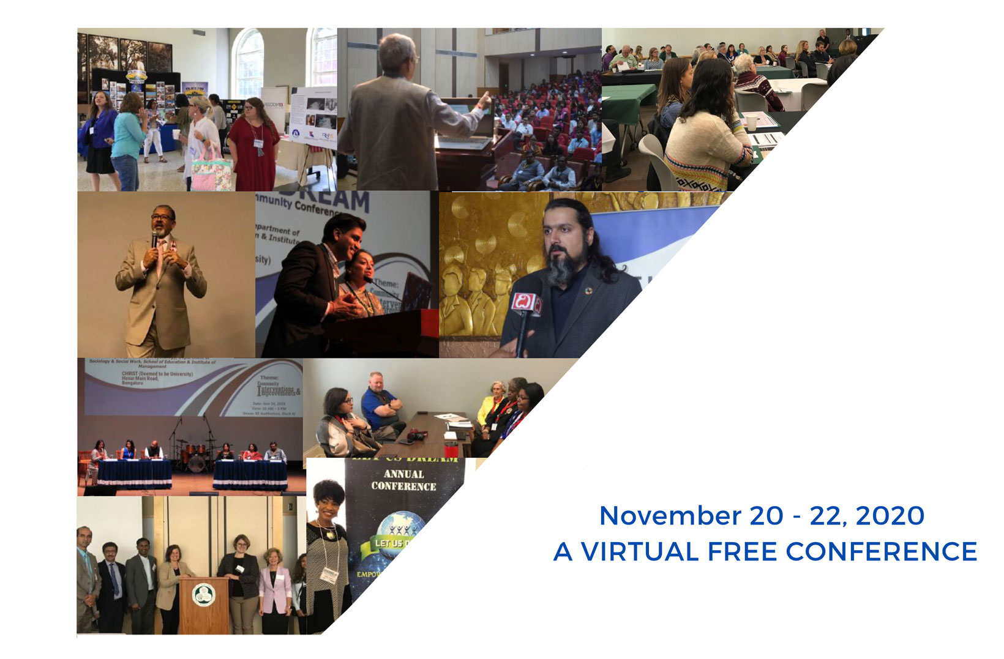

## **EMPOWERING COMMUNITIES**



This year will mark the first Triennial International LET US DREAM Conference. The international conference offers an opportunity to explore and share the many and varied community-service possibilities and intervention models, as well as volunteer opportunities for younger and older generations. The primary intent is to create an inclusive, diverse, cross-cultural environment for sharing and growth through community improvement discourse among scholars, practitioners, and volunteers of all ages.



**Empowering local communities for sustainable global impact and improvement.**



* To improve international networking and collaboration among all those interested in community improvement organizations and programs;
* To promote volunteerism and empower all those involved in local and global community improvement organizations and initiatives, including employees, volunteers, post-secondary students, researchers, and practitioners;
* To create a professional learning global community dedicated to improving local communities characterized by a diverse and inclusive culture of shared researcher and practitioner knowledge, skills, theories, and best practices.

## **CONFERENCE TENTATIVE SCHEDULE**

## **Date: Nov 20-22, 2020**

## **Time: 7.00 PM – 9.30 PM (IST)**

### **Welcome: (3 Mins)**

### **Official Opening: (5 Mins)**

### **Opening Keynote: (25 Mins)**

### **Panel Breakout: (40 Mins)**

### **Unsung heroes: (20 Mins)**

### **Closing Keynote: (25 Mins)**

### **Closing remarks: (5 Mins)**

### **Virtual Music Band: (10 Mins)**

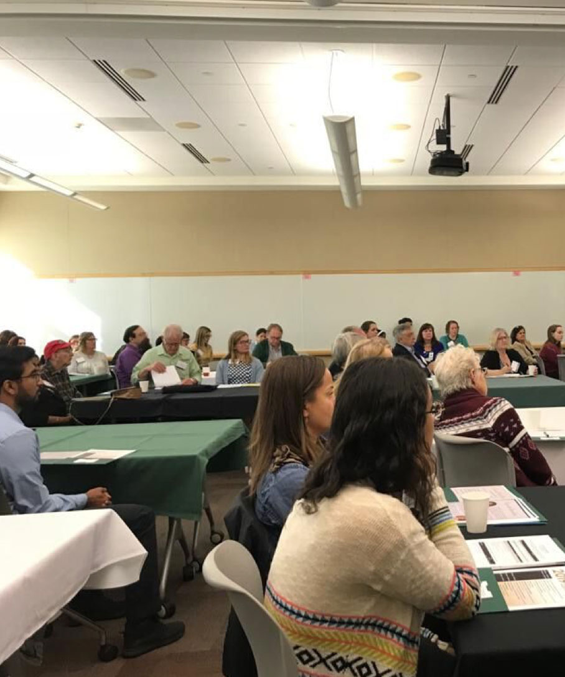

## **UNIQUE FEATURES**



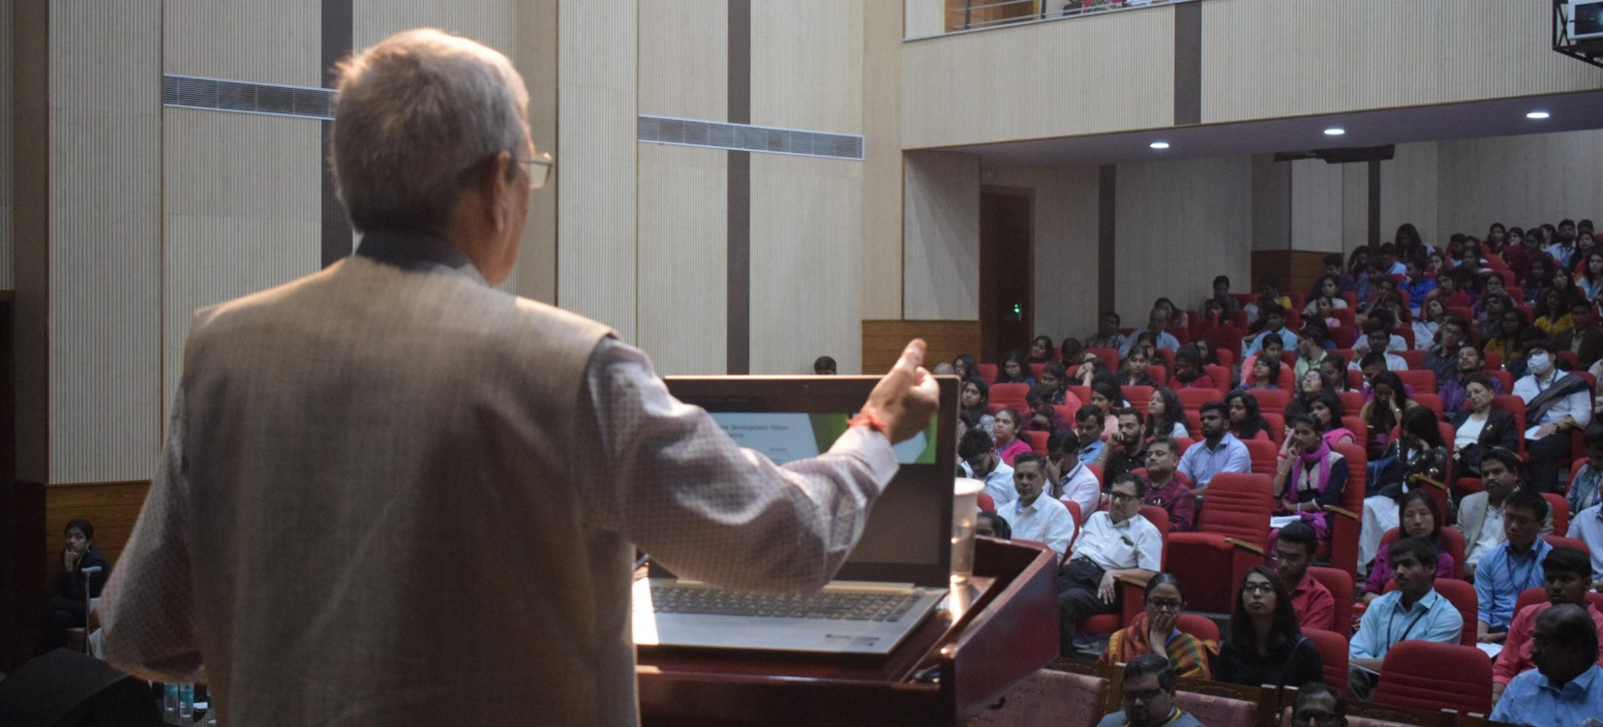

Each day will feature two internationally renowned keynote speakers addressing the major topic of the day (i.e., Education, Health, or Social Service). The first keynoter will speak from a research-based perspective and the second from a practitioner perspective.



Following the opening keynote, there will be an opportunity to attend one of three parallel panel discussions. Each panel discussion will focus on a different theme pertaining to the day’s topic. Conference participants will select one of the three sessions to attend.



Each day unsung heroes—change makers selected from an international pool of recommended individuals—will be recognized and celebrated and provided time to share their inspirational stories.

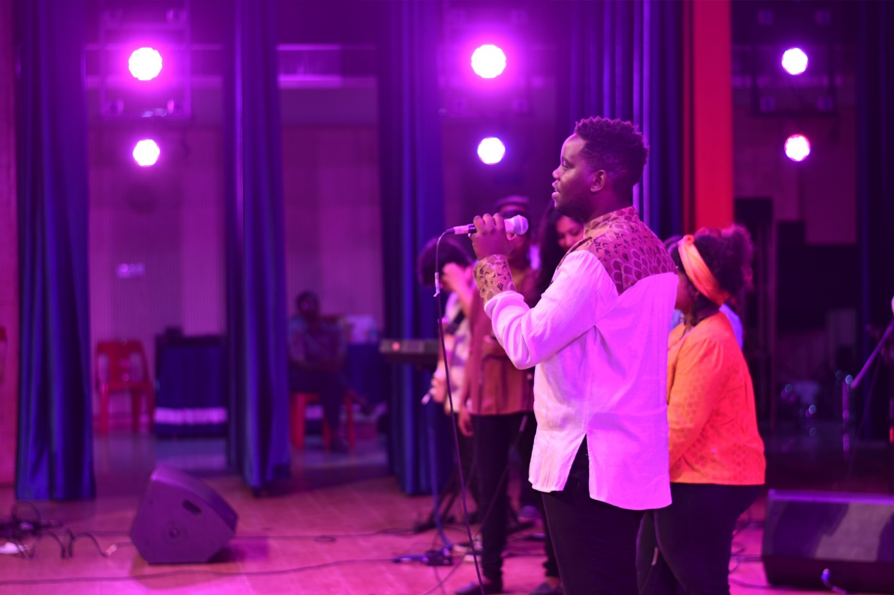



Musicians from around the world will come together to sing songs that promote global harmony, healing, collaborative growth, and success—all of which reflect the conference message of local and global shared communities.



### **Dr. Dhanajeyan Jayavel**

### **Mr. David Sevaraj**

### **Ms. Anita Eipe**



### **Dr. Pauline Leonard**



### **Ms. Unnati Hunjan**

### 



### **Fr Lijo Thomas**



### **Central Campus, CHRIST University, Hosur Road, Bangalore – India 560029**

### **Call – +91 7204724060**

### **Email – conference@letusdream.org**